Lab 5

Group 24

Group members:

24280001 Yahya Habib

24280033 Ameer Hamza

Music Event Production

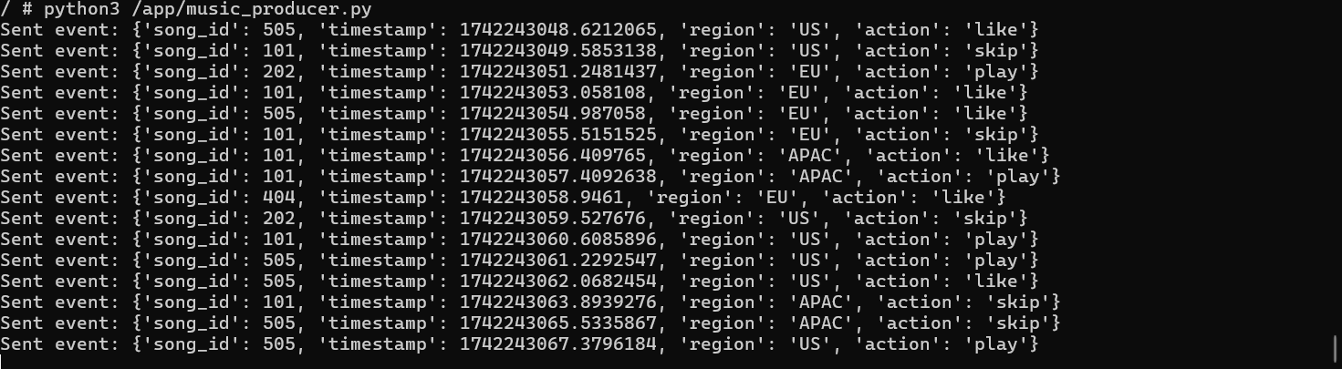

Now Trending Batches

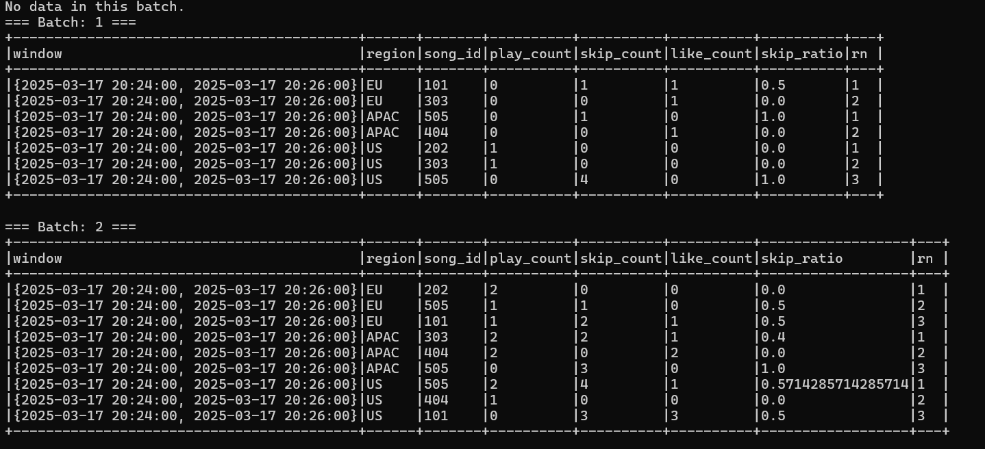

**Analysis:** Changing micro-batch intervals results in faster updates regarding trending music. We can say that system struggles to keep up to real time speed in data sync. Resulting in delays fetching data. Every Batch has different songs thus having different metric results